**STEP BY STEP PROCESS FOR USING RALLY TEST SCRIPT UPLOADER UTILITY**

**Installation Steps:-**

**Step 1:-**Double click the application.

**Step 2:-** The app will download JRE1.7 on your System if the JRE doesn’t exists. Please install the JRE manully. Once you have installed the JRE on your System and you have restarted the application. The application will set the PATH variable to the JRE installation path.

**NOTE :-** The App is designed for 64 bit OS and if you want to use the app on 32 bit OS please install JRE 1.7 for Win 32 bit and manually set the PATH variable in your System to - C:\Program Files (x86)\Java\jre7

**Steps for using the rally test script uploaded utility:-**

**Step 1:-** Select the input test file with the test script data. The Test script has to present in the first sheet of the input Test script.

The format of the test script should be as shown below. The order of the column name can be anything you like for the 3 columns(Test Scenario ID, Test Scenario

and Test Condition ID).

The Column (Test Steps, Test Step Expected Result) has to be the 4th and 5th Column respectively in the input test script.

|  |  |  |  |  |
| --- | --- | --- | --- | --- |
| **Test Scenario ID** | **Test Scenario** | **Test Condition ID** | **Test Steps** | **Test Step Expected Result** |

**NOTE :-** The data is processed on the basis of the Test Script column. The test column name has to be exactly the same as described above (The test script column name is case sensitive).

Please find attached a sample input test script.

**Step 2:-** Click the ‘Process test script’ button .This action will be process the input test script data and the save the required data in the memory.

You can see the progress in processing the test script data on the progress monitor bar.

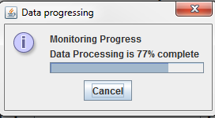

**Step 3:-** Enter the required details in the text boxes provided.

**Note:-** It is recommended to enter the corresponding values for the fields, if the values as same for most of the test scenarios. You can also enter the values in the output excel sheet generated.

**Step 4:-** Select the Output Excel sheet file and click on ‘Generate the Output Script’ Button.

**Step 5:-** The final test script that you can upload to the Rally web application will be generated and you will get a message as shown below.

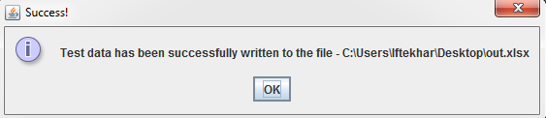

Please find a sample output script attached.

**Instances where Exception can occur due to an issue in the test Script data.**

1. The ‘Test Scenario IDs’ should not be in non-decreasing order. If the test scenario IDs are in non-decreasing order then you will get the below exception.

**com.open.rallyuploader.exeption.RallyUploaderException: The test scenerio IDs are not in non incresing order.Please verify!!**

1. The ‘Test Scenario’ description has to be unique for each of the test Scenario ID. There should be a one-one mapping between the test scenario ID and test scenario description.

* If a particular Test scenario ID has more than one test scenario description then you will get the below exception.

**com.open.rallyuploader.exeption.RallyUploaderException: The Scenerio descriptions are duplicate.Please verify!!**

* If one or more test scenario IDs has the same test scenario description. Then you will get the below exception:-

**com.open.rallyuploader.exeption.RallyUploaderException: One or more test scenerio IDs have more than one test scenerio description.Please verify!!**

1. If you do not select the input test script file and you have clicked on the Process test Script’ button. Then you will get the below exception.

**com.open.rallyuploader.exeption.RallyUploaderException: Please select the input file.**

1. If you have not selected the Output script file and you have clicked on ‘Generate output script’ then you will get the below exception.

**com.open.rallyuploader.exeption.RallyUploaderException: Please select the output file.**

1. The test scenario ID has to be in the below format. If the Test scenario is not the format specified. Then you will get Number format Exception.

<Some String>_TS <numerical value>

**NOTE:-** You also check the exception in the log file C:\ rallyuploaderutility.log

1. If any of the Column name is not as already discussed.You will get an exception stating that the Column does not exist.

**Once any exception has occurred please click on close button on the Exception Dialog box and restart the Rally test script uploader application.**